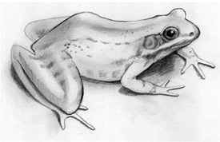
Frog Dissection Project Due: Friday May 29th
Your group will create a visual presentation of the structures below:

- dorsal
- ventral
- maxillary teeth
- vomerine teeth
- nares/nostrils
- esophagus
- tongue
- tympanic membrane
- heart
- lungs
- liver
- stomach
Identify these structures based on the sex of your frog. (not included in your powerpoint)
Males:
- testis
- fat bodies
Females:
- oviduct/ovaries
- eggs (if present)
- cloaca
- kidney
- large intestine
- small intestine

Requirements:
- Cover slide – includes logo, student names, and hour
- I structure per picture
  - Group Logo in each picture (no duplicates)
  - Isolate each structure with the probe in each picture
  - Structure’s name or label “flies” in second for studying purposes
- 2 pictures per slide
- Turn in on your teacher’s flash drive for grading purposes.

